
Fundamentals Of Operating
System Lab (ENCA252)

Lab File
Submitted by: Karan singh(2401201148)

Submitted to
Ms. Jyoti Yadav

School of Engineering & Technology

OPERATING SYSTEM LAB – ASSIGNMENT 1
Topic: Implementation and Analysis of CPU Scheduling Algorithms (FCFS & SJF)

---

### 1. Aim

To implement First Come First Serve (FCFS) and Shortest Job First (SJF) scheduling algorithms and analyze their performance using parameters such as Completion Time (CT), Turnaround Time (TAT), and Waiting Time (WT).

---

### 2. Theory

CPU Scheduling is a process by which the operating system decides which process will execute next. It helps in efficient utilization of CPU.

FCFS (First Come First Serve):
- Processes are executed in the order of their arrival time.
- It is a non-preemptive scheduling algorithm.
- Simple but may lead to higher waiting time.

SJF (Shortest Job First):
- Process with the smallest burst time is executed first.
- It minimizes average waiting time.
- Also non-preemptive in this implementation.

---

### 3. Algorithm

FCFS Algorithm:
- Sort processes based on arrival time.
- Execute each process in order.
- Calculate CT, TAT = CT − AT, WT = TAT − BT.

SJF Algorithm:
- Select processes that have arrived.
- Choose process with minimum burst time.
- Execute and repeat until all processes complete.

---

### 4. Code

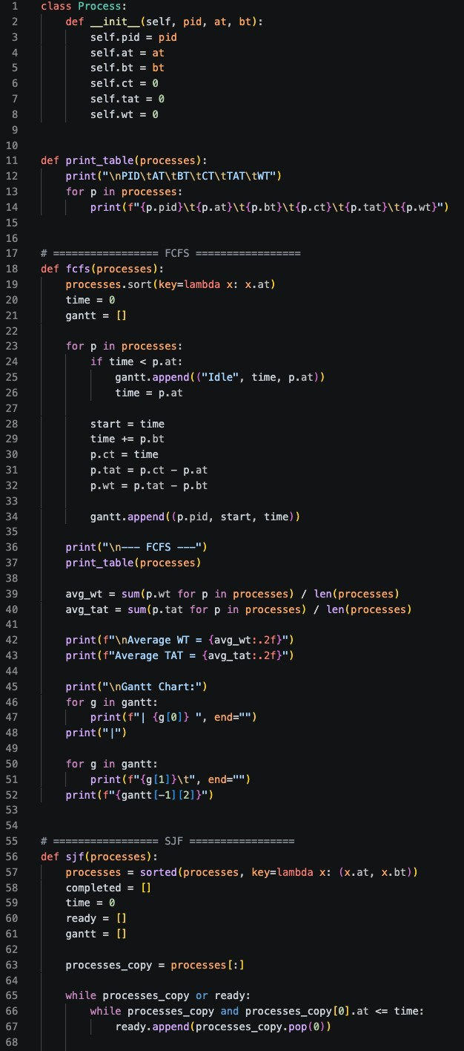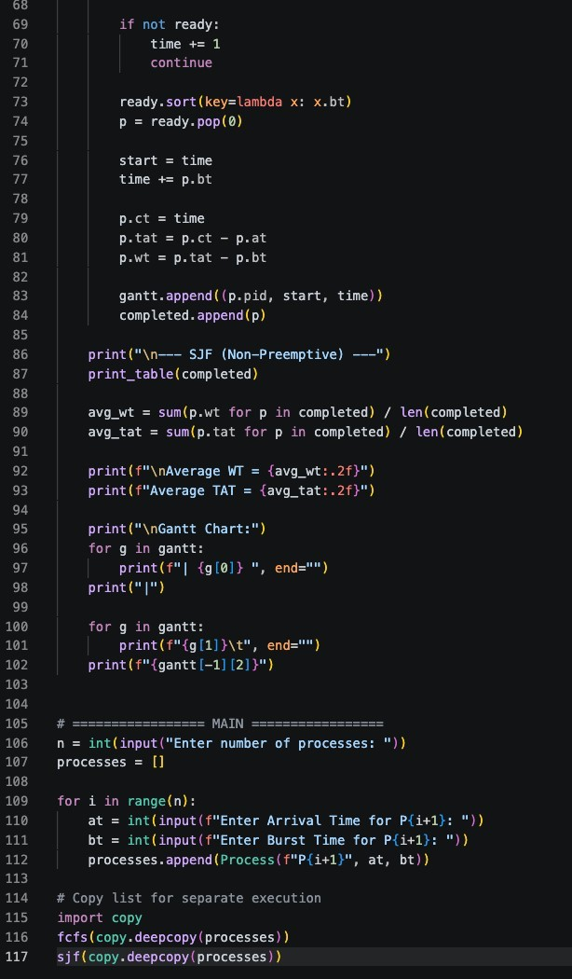

---

### 5. Input Used

Example Input:

Number of Processes = 5

| Process | AT | BT |
|--------|----|----|
| P1 | 0 | 8 |
| P2 | 1 | 4 |
| P3 | 2 | 9 |
| P4 | 3 | 5 |
| P5 | 4 | 2 |

---

### 6. Output
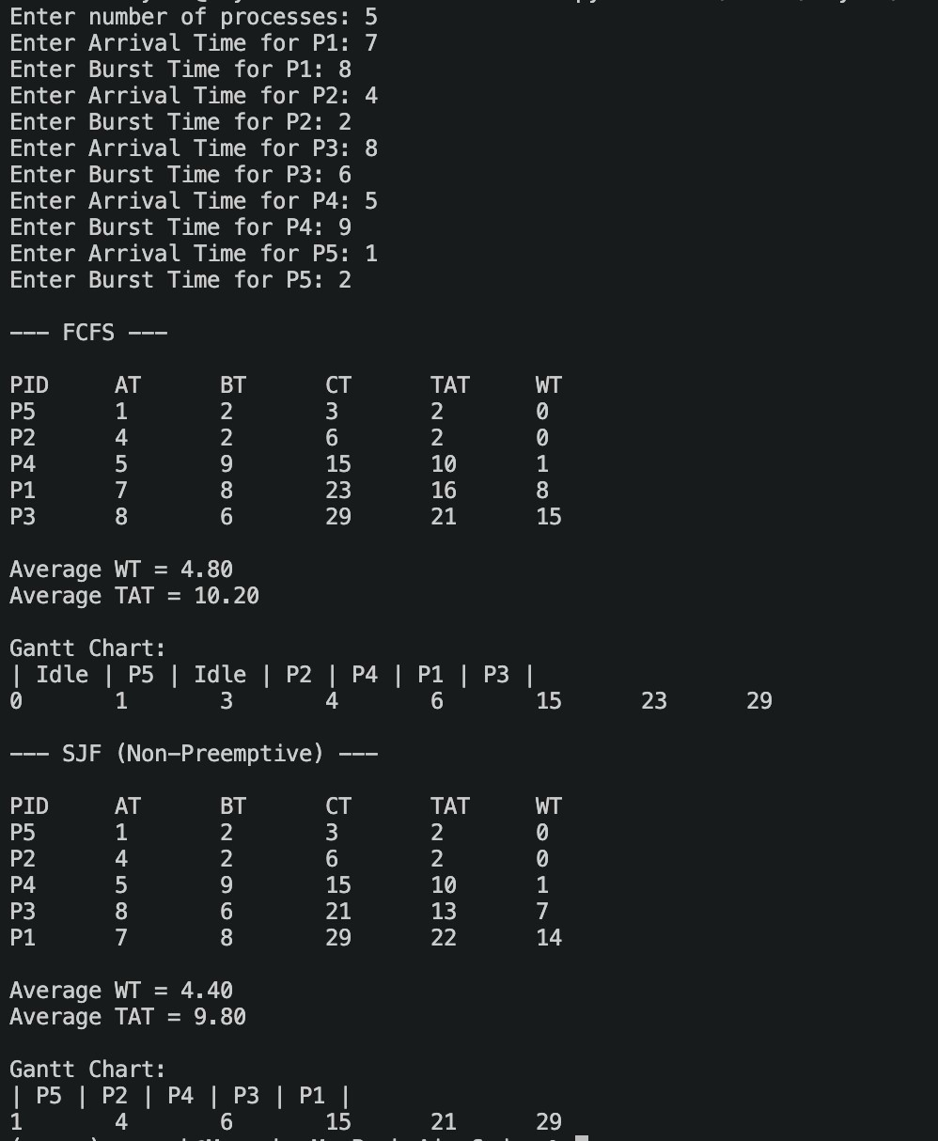

- FCFS Output Table
- SJF Output Table
- Gantt Charts

---

### 7. Result

- FCFS executes processes in arrival order, which may lead to higher waiting time.
- SJF selects the shortest job first, reducing the average waiting time.
- From the results, it is observed that SJF performs better than FCFS in terms of efficiency.

---

### 8. Conclusion

CPU scheduling plays an important role in process management.
Among the two algorithms implemented, SJF provides better performance by minimizing waiting time, while FCFS is simpler but less efficient.

---

### 9. GitHub Link

(https://github.com/MayankCh-Work/os-lab-assignments.git )



